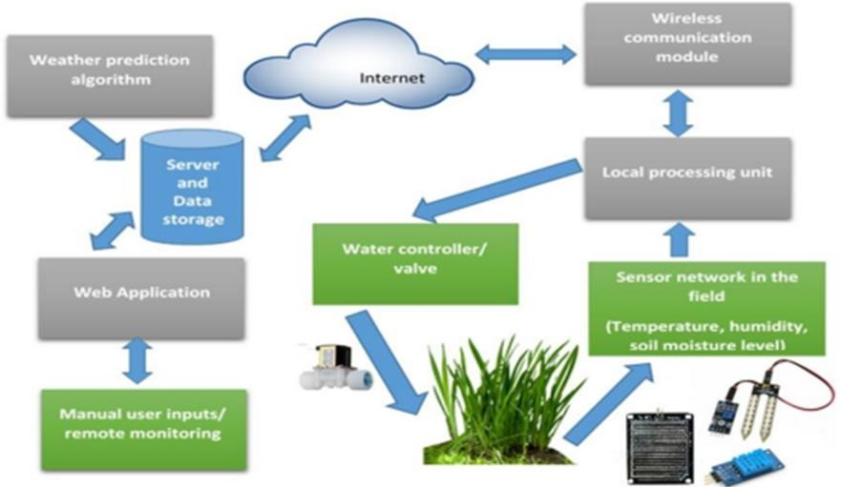

Project Design Phase-II

Data Flow Diagram & User Stories

|  |  |
| --- | --- |
| Date | 01 October 2022 |
| Team ID | PNT2022TMID08745 |
| Project Name | Project - SmartFarmer-IOT Enabled Smart Farming  Application |
| Maximum Marks | 4 Marks |

# Data Flow Diagrams:

A Data Flow Diagram (DFD) is a traditional visual representation of the information flows within a system. A neat and clear DFD can depict the right amount of the system requirement graphically. It shows how data enters and leaves the system, what changes the information, and where data is stored.

Example: DFD Level 0 (Industry Standard)

# Example: [(Simplified)](https://developer.ibm.com/patterns/visualize-unstructured-text/)

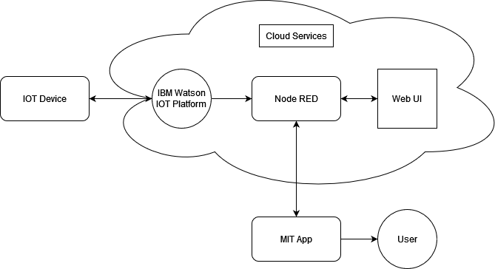

**User Stories**

Use the below template to list all the user stories for the product.

|  |  |  |  |  |  |  |
| --- | --- | --- | --- | --- | --- | --- |
| **User Type** | **Functional Requirement**  **(Epic)** | **User Story Number** | **User Story / Task** | **Acceptance criteria** | **Priority** | **Release** |
| Customer (Mobile user) | Registration | USN-1 | As a user, I can register for the application by entering my email, password, and confirming my password. | I can access my account / dashboard | High | Sprint-1 |
|  |  | USN-2 | As a user, I will receive confirmation email once I have registered for the application | I can receive confirmation email & click confirm | Medium | Sprint-1 |
|  |  | USN-3 | As a user, I can register for the application through Facebook | I can register & access the  dashboard with Facebook Login | Low | Sprint-1 |
|  |  | USN-4 | As a user, I can register for the application through Gmail |  | Medium | Sprint-1 |
|  | Login | USN-5 | As a user, I can log into the application by entering email & password |  | High | Sprint-1 |
|  | Dashboard | USN-6 | As a user I want to see everything in single widget |  | Medium | Sprint-2 |
|  |  | USN-7 | As a user I want a organized widgets section |  | High | Sprint-2 |
|  |  | USN-8 | As a user I want a graphical/pictorial representation |  | Low | Sprint-2 |
| Customer (Web User) | Dashboard | USN-9 | As a user I want a graphical representation of data for better understanding |  | High | Sprint-2 |
|  |  | USN-10 | As a user I want to see a dashboard where I can customize myself | Dashboard with customization | Low | Sprint-2 |
| Customer  (Mobile and Web) | IoT Device Setup | USN-10 | Have to use a least sensor and get better output |  | High | Sprint-2 |
|  |  | USN-11 | As a user, I need a low cost IoT devices for farming |  | High | Sprint-2 |
|  |  | USN-12 | As a user, I need a multiple sensors for various data |  | High | Sprint-2 |

|  |  |  |  |  |  |  |
| --- | --- | --- | --- | --- | --- | --- |
| **User Type** | **Functional Requirement (Epic)** | **User Story Number** | **User Story / Task** | **Acceptance criteria** | **Priority** | **Release** |
| Customer Care Executive | User Problems | USN-13 | As a user, I don’t how to use the application | Manual guide will be there | Medium | Sprint-3 |
|  |  | USN-14 | As a user, I need my application to work on most of the mobiles |  | High | Sprint-3 |
|  |  | USN-15 | As a user, I am facing issue in the application | Query form will be there | High | Sprint-3 |
| Administrator | Query Clarification | USN-16 | As a admin, I give solutions to their queries |  | High | Sprint-3 |
|  | Particular Access | USN-17 | As a admin, I give access only to authorized person |  | High | Sprint-3 |
|  | Connection with IOTdevices | USN-18 | As a admin, I ensure the correct working of the devices. If any problem arises it will be shared to user |  | Medium | Sprint-4 |
| Customer (Mobile user) | Application | USN-19 | As a user, I need to control my devices | Commands for devices | High | Sprint-4 |
|  |  | USN-20 | As a user, I need a events for better productivity |  | Low | Sprint-4 |
|  |  | USN-21 | As a user, I need a more info about plants inside a application |  | Medium | Sprint-4 |